Power BI Assignment Report
Executive Summary & Technical Documentation

Student Name: | Okeoghene Amromanoh
Student ID: | NF1034798
Date: | May 16th
Assignment Title: | Data Transformation & Visualization in Power BI

1. Power Query / ETL Process

1.1 Data Import & Renaming
The following data files were imported and renamed for better readability within the model:
Original Name | Renamed Table
DimVehicle | Vehicle Table
Dim Calendar Table | Calendar Table
DimColor | Color Table
DimLocation | Location Table
DimSeller | Seller Table
DimTransmission | Transmission Table
FactVehicleSale | Fact VehicleSale Table

1.2 Data Profiling & Quality Inspection
Comprehensive profiling was performed to identify data quality issues:
Issue Category | Finding | Action Taken
Missing Values
Outliers
Empty Strings | In color table exterior and interior  In Transmission Table, empty str for transmission type | Replaced empty with “unknown”  Conditional column replaced empty transmission type with “not specified”
Inconsistent Types | Sedan & sedan – inconsistent type in transmission | Conditional column replacing with “not specified”

1.3 Custom Transformations

Calendar Table Enhancements
The following fields were added to the Calendar Table:
- Start of the Year
- Year
- Start of the Month
- Month
- Month Name
- Week of the Year

Vehicle Profile Calculation
A "Vehicle Profile" column was created by merging [Make], [Model], and [Body] using a "Hyphen" separator.

1.4 Transformation Log
Removed duplicates in all tables
Handled empties by replacing with “unknown” where fit
Created conditional to handle empty and inconsistent values in transmission table, rename new ccolumn transmission and removed old table
Removed empty values in condition table
Created new column “Vehicle Profile” by merging make, model and body in vehicle table
Added New index column from the date column in calendar table
Noticed Lack of matching columns between fact table and calendar table. Created new calendar table to match date Id in the fact table and original dates in the original calendar table… NEW Calendar table is called “calendar id specified” it connects directly to the fact table as a juncture between the calendar and the fact table

2. Data Modeling

2.1 Schema Design
The model is built using a Star Schema. Primary keys have been marked in the properties pane to establish 1:Many relationships.

2.2 Data Integrity Check (Matrix Visual)
Below is a Matrix Visual verification showing fields from every table to confirm the relationships are functioning correctly:
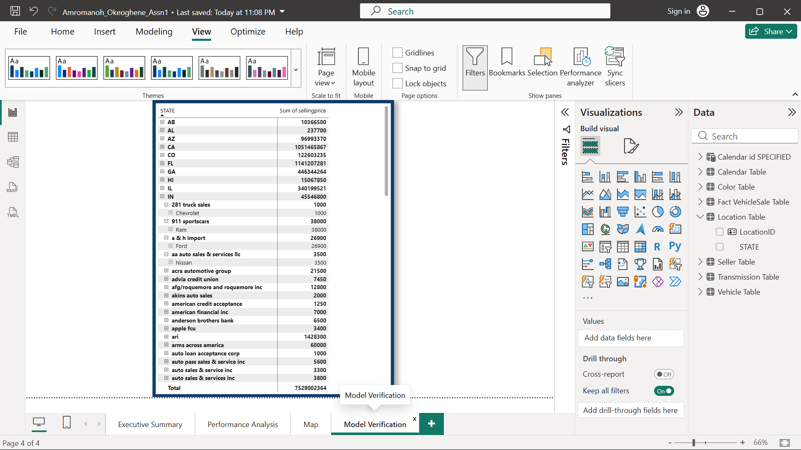

3. DAX Measures
Minimum of 10 measures were created across various functional categories:
Category | Measure Name | DAX Formula
Math & Stat | Total Revenue  (Calculates the gross expected revenue by summing the selling price)  Average Sales Price  (Calculates the average price at which vehicles are being sold)  Max Vehicle Price  (Identifies the highest priced vehicle sold in the selected context) | SUM('Fact VehicleSale Table'[sellingprice])  AVERAGE('Fact VehicleSale Table'[sellingprice])  MAX('Fact VehicleSale Table'[sellingprice])
Counting | Total Vehicles Sold  (Counts the total number of sales transactions)  Unique Vehicles Available  (Counts the distinct number of vehicles in your inventory/dimension table) | COUNTROWS(Total Vehicles Sold = COUNTROWS('Fact VehicleSale Table')  )  DISTINCTCOUNT('Fact VehicleSale Table'[VehicleID])
Logical/Cond. | Sales Performance Status  (Evaluates the Average Sales Price and returns a text status based on conditional threshold)  Sales Volume Rating  (evaluate performance against a rule set and outputs rating) | IF(  [Average Sale Price] >= 40000,  "Premium Tier",  "Standard Tier"  )  SWITCH(  TRUE(),  [Total No_Vehicles Sold] > 500, "Excellent",  [Total No_Vehicles Sold] > 200, "Good",  "Needs Improvement"  )
Calculate | High Value Sales  (Calculates total revenue, but filters only for transactions where the sales price exceeds $50,000) | CALCULATE(  [Total Revenue],  'Fact VehicleSale Table'[sellingprice] > 50000  )
Time Intelligence | Total Sales YTD | TOTALYTD(  [Total Revenue],  'Calendar Table'[Date]  )
All Time | Total Sales (All Time)  (Calculates total revenue while ignoring any filters applied to the Calendar Table, useful for calculating percentages of totals)  Sales Previous Year  (Shifts the current filter context back by exactly one year to compare historical performance)  YoY Sales Growth  (Calculates the percentage change in sales revenue compared to the previous year, using DIVIDE to safely handle any division-by-zero errors.) | CALCULATE(  [Total Revenue],  ALL('Calendar Table')  )  CALCULATE(  [Total Revenue],  SAMEPERIODLASTYEAR('Calendar Table'[Date])  )  DIVIDE(  [Total Revenue] - [Sales Previous Year],  [Sales Previous Year],  0  )

4. Visualization & Reporting

4.1 Report Layouts
The report explores relationships between parameters using the following visual types:
- Bar Charts (Categorical Analysis)
- Pie/Donut Charts (Composition)
- Line Charts (Time Series)
- Interactive Slicers (Filtering)
- Card

4.2 Limitations and Optimization
Limitation The initial data model lacked temporal alignment because the hardcoded calendar dimensions mismatched the underlying transaction dates, causing critical referential integrity bugs and unallocated "Blank" categories in the visual reporting.
The Optimization: To restore data model integrity, a dynamic DAX CALENDAR table was constructed using ADDCOLUMNS to automatically anchor the temporal boundaries directly to the minimum and maximum years present in the fact table.
The Result: This optimization eliminated structural orphan rows, streamlined the multi-table Star Schema relationships, and restored chronological sorting across all visual axes without relying on manual filter overrides.

4.3 Dashboard Screenshots

